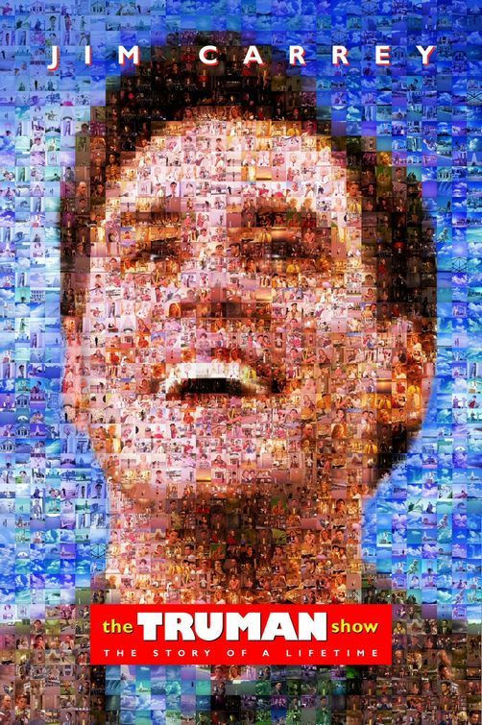
Name_________________________

Media I
February 25-29, 2016
Mr. Bastos
Period _______
PLEASE TAKE NOTES on this page, and HAND-WRITE COMPLETE ANSWERS 2-4 sentences due March 8, 2016 (40 pts)
- At the beginning of the film, Christof describes Truman’s scenario – what does he mean when he says, “There is nothing fake about Truman…”?

- How is Truman’s relationship with his surrounding vastly different than the interactions of a normal person? How or why does the audience perceive this as real?

- The theme of the film is, as Christof stated, “We accept the reality of the world which we are presented.” Do you agree or disagree? Support your assertion with real-world examples.

- Walden said that men “lead lives of quiet desperation.” Give at least three examples from the film supporting this assertion.

- Christof asserts his defense of keeping Truman in Seahaven – defending it by calling Seahaven, “the way the world should be. The world you live in is the sick place.” Compare Truman’s sacrifice of freedom for safety to our protection of liberty – and lack of full protection.

- Throughout the film, producers insert product placements shamelessly. Cite three examples of this in reality. One example – naming of stadiums – like PNC Park.

- Discuss how product placement was important to the survival of the television show, the Truman Show.

- In the film, Truman confronts numerous obstacles – the dog on the bridge, his teacher telling him there is nowhere left to explore, his father keeping him from the rocks, unhelpful travel agent, etc. To what extent are we subtle products of our OWN environments. Cite three specific examples supporting and refuting.

- Emerson stated, “Whoever so be a man must be a non-conformist.” Would Truman be a man? If so, when was the occasion he became one?

- Christof clearly has an obsession with his own God complex. In what ways is he similar to God, and what ways is he different? Cite three examples.

- Christof stated the following: HE CAN LEAVE AT ANY TIME. If his was more than just a vague ambition, if he was absolutely determined to discover the truth, there’s no way that we could prevent him.” To what extent do you agree or disagree?

- When Truman begins to piece together his own reality, he begins to question nearly all in Seahaven. Describe an incident in your own life that called nearly everything in your own life into question, and discuss how you responded.

- At the end of the film, would you choose to remain in Seahaven, or leave? Defend your response using evidence from the film.

- The film, the Truman Show, was released in 1998. The first large scale reality Show, Survivor, was released in 2000. How did Truman Show’s prediction of Truman Show accurately reflect reality television, and how was it wrong?

- Another theme of the film might be a man vs. society – that a person can acquire knowledge – even if a society is determined to disguise it. Through persistence truth can be discovered. Is this an accurate reflection? Or are real truths still disguised?

